**Additional Exercise**

**Display Employee List and Edit Employee form using RESTful Web Service**

**Employee.java**

package com.cognizant.springapp.model;

public class Employee {

private int id;

private String name;

private double salary;

public Employee() {

System.***out***.println("Inside Employee Constructor");

}

public int getId() { return id; }

public void setId(int id) { this.id = id; }

public String getName() { return name; }

public void setName(String name) { this.name = name; }

public double getSalary() { return salary; }

public void setSalary(double salary) { this.salary = salary; }

*@Override*

public String toString() {

return "Employee{id=" + id + ", name='" + name + "', salary=" + salary + '}';

}

}

**employee.xml**

<?**xml** version=*"1.0"* encoding=*"UTF-8"*?>

<**beans** xmlns=*"http://www.springframework.org/schema/beans"*

xmlns:xsi=*"http://www.w3.org/2001/XMLSchema-instance"*

xsi:schemaLocation=*"http://www.springframework.org/schema/beans*

*https://www.springframework.org/schema/beans/spring-beans.xsd"*>

<**bean** id=*"employee1"* class=*"com.cognizant.springapp.model.Employee"*>

<**property** name=*"id"* value=*"1"*/>

<**property** name=*"name"* value=*"John Doe"*/>

<**property** name=*"salary"* value=*"50000"*/>

</**bean**>

<**bean** id=*"employee2"* class=*"com.cognizant.springapp.model.Employee"*>

<**property** name=*"id"* value=*"2"*/>

<**property** name=*"name"* value=*"Jane Smith"*/>

<**property** name=*"salary"* value=*"60000"*/>

</**bean**>

<**bean** id=*"employeeList"* class=*"java.util.ArrayList"*>

<**constructor-arg**>

<**list**>

<**ref** bean=*"employee1"*/>

<**ref** bean=*"employee2"*/>

</**list**>

</**constructor-arg**>

</**bean**>

</**beans**>

**EmployeeController.java**

package com.cognizant.springapp.controller;

import com.cognizant.springapp.model.Employee;

import org.springframework.context.ApplicationContext;

import org.springframework.context.support.ClassPathXmlApplicationContext;

import org.springframework.web.bind.annotation.*;

import java.util.List;

@RestController

@CrossOrigin(origins = "*") // Allow access from Angular

public class EmployeeController {

@GetMapping("/employees")

public List<Employee> getAllEmployees() {

ApplicationContext context = new ClassPathXmlApplicationContext("employee.xml");

List<Employee> employees = (List<Employee>) context.getBean("employeeList");

return employees;

}

@GetMapping("/employees/{id}")

public Employee getEmployeeById(@PathVariable int id) {

ApplicationContext context = new ClassPathXmlApplicationContext("employee.xml");

List<Employee> employees = (List<Employee>) context.getBean("employeeList");

return employees.stream()

.filter(emp -> emp.getId() == id)

.findFirst()

.orElse(null);

}

}

**SpringappApplication.java**

package com.cognizant.springapp;

import org.springframework.boot.SpringApplication;

import org.springframework.boot.autoconfigure.SpringBootApplication;

@SpringBootApplication

public class SpringappApplication {

public static void main(String[] args) {

SpringApplication.run(SpringappApplication.class, args);

}

}

**Output:**

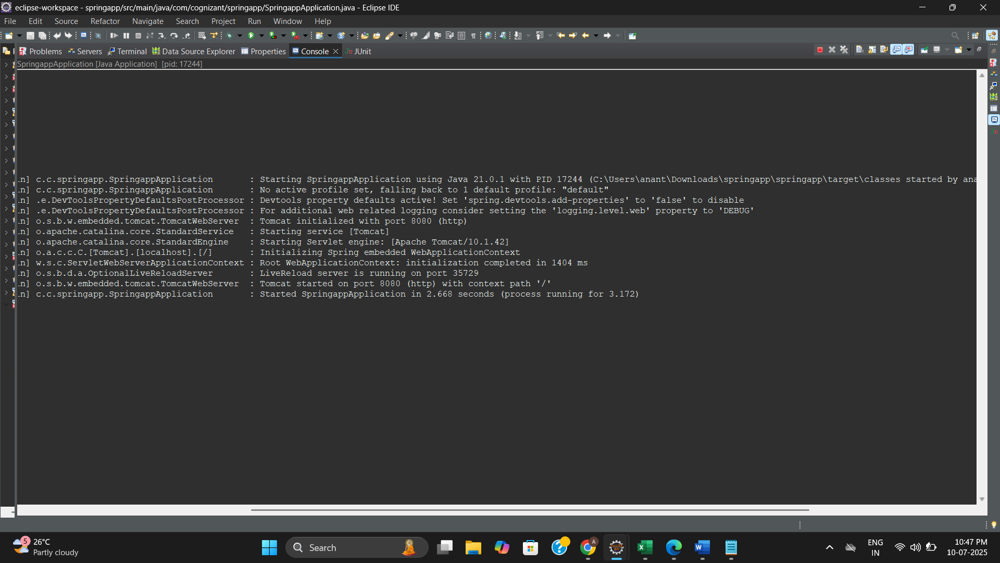

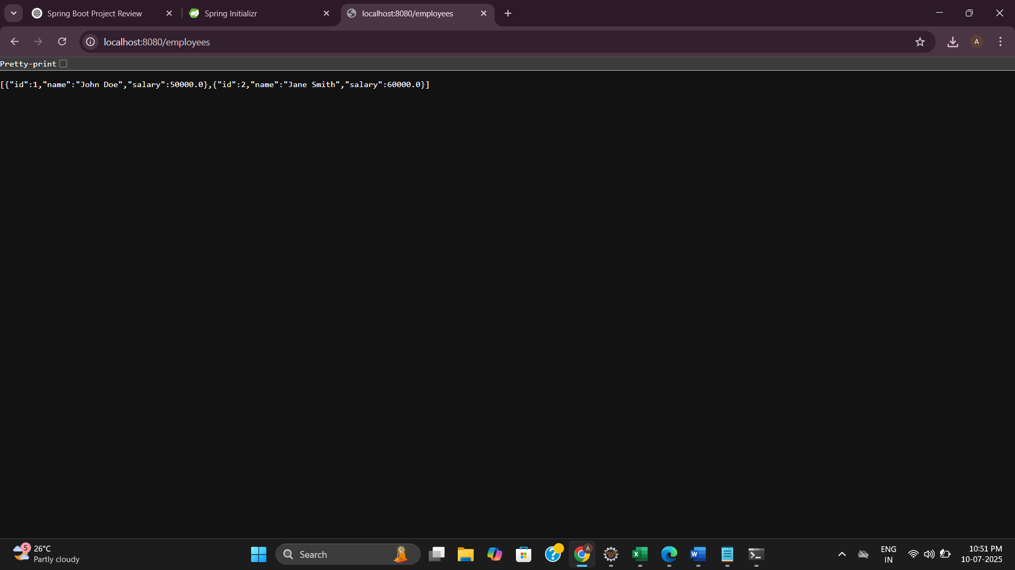

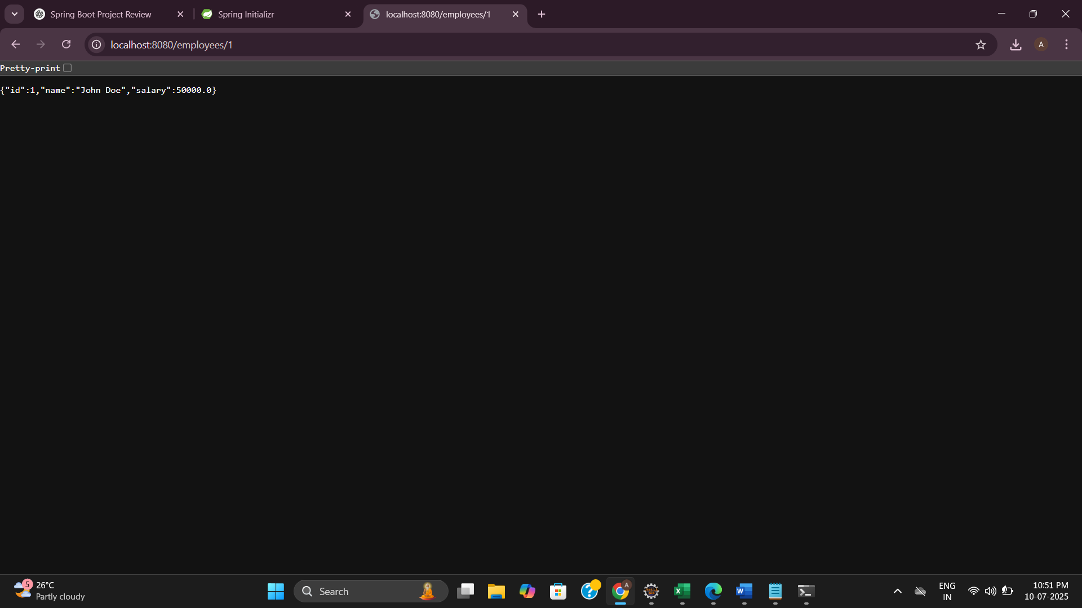

**Create static employee list data using spring xml configuration**

**Employee.java**

package com.cognizant.model;

import java.util.List;

public class Employee {

private int id;

private String name;

private Department department;

private List<Skill> skillList;

public Employee() {}

public Employee(int id, String name, Department department, List<Skill> skillList) {

this.id = id;

this.name = name;

this.department = department;

this.skillList = skillList;

}

public int getId() {

return id;

}

public void setId(int id) {

this.id = id;

}

public String getName() {

return name;

}

public void setName(String name) {

this.name = name;

}

public Department getDepartment() {

return department;

}

public void setDepartment(Department department) {

this.department = department;

}

public List<Skill> getSkillList() {

return skillList;

}

public void setSkillList(List<Skill> skillList) {

this.skillList = skillList;

}

*@Override*

public String toString() {

return "Employee{" +

"id=" + id +

", name='" + name + '\'' +

", department=" + department +

", skillList=" + skillList +

'}';

}

}

**Department.java**

package com.cognizant.model;

public class Department {

private int id;

private String name;

public Department() {}

public Department(int id, String name) {

this.id = id;

this.name = name;

}

public int getId() {

return id;

}

public void setId(int id) {

this.id = id;

}

public String getName() {

return name;

}

public void setName(String name) {

this.name = name;

}

*@Override*

public String toString() {

return "Department{" +

"id=" + id +

", name='" + name + '\'' +

'}';

}

}

**Skill.java**

package com.cognizant.model;

public class Skill {

private int id;

private String name;

public Skill() {}

public Skill(int id, String name) {

this.id = id;

this.name = name;

}

public int getId() {

return id;

}

public void setId(int id) {

this.id = id;

}

public String getName() {

return name;

}

public void setName(String name) {

this.name = name;

}

*@Override*

public String toString() {

return "Skill{" +

"id=" + id +

", name='" + name + '\'' +

'}';

}

}

**EmployeeDao.java**

package com.cognizant.dao;

import com.cognizant.model.Employee;

import org.springframework.context.ApplicationContext;

import org.springframework.context.support.ClassPathXmlApplicationContext;

import java.util.ArrayList;

import java.util.List;

public class EmployeeDao {

private static ArrayList<Employee> *EMPLOYEE_LIST*;

public EmployeeDao() {

ApplicationContext context = new ClassPathXmlApplicationContext("employee.xml");

*EMPLOYEE_LIST* = (ArrayList<Employee>) context.getBean("employeeList");

}

public List<Employee> getAllEmployees() {

return *EMPLOYEE_LIST*;

}

}

**employee.xml**

<?**xml** version=*"1.0"* encoding=*"UTF-8"*?>

<**beans** xmlns=*"http://www.springframework.org/schema/beans"*

xmlns:xsi=*"http://www.w3.org/2001/XMLSchema-instance"*

xsi:schemaLocation=*"http://www.springframework.org/schema/beans*

*http://www.springframework.org/schema/beans/spring-beans.xsd"*>

<!-- Skills -->

<**bean** id=*"skillJava"* class=*"com.cognizant.model.Skill"*>

<**property** name=*"id"* value=*"1"*/>

<**property** name=*"name"* value=*"Java"*/>

</**bean**>

<**bean** id=*"skillPython"* class=*"com.cognizant.model.Skill"*>

<**property** name=*"id"* value=*"2"*/>

<**property** name=*"name"* value=*"Python"*/>

</**bean**>

<!-- Departments -->

<**bean** id=*"deptIT"* class=*"com.cognizant.model.Department"*>

<**property** name=*"id"* value=*"101"*/>

<**property** name=*"name"* value=*"IT"*/>

</**bean**>

<**bean** id=*"deptHR"* class=*"com.cognizant.model.Department"*>

<**property** name=*"id"* value=*"102"*/>

<**property** name=*"name"* value=*"HR"*/>

</**bean**>

<!-- Employees -->

<**bean** id=*"employee1"* class=*"com.cognizant.model.Employee"*>

<**property** name=*"id"* value=*"1001"*/>

<**property** name=*"name"* value=*"Alice"*/>

<**property** name=*"department"* ref=*"deptIT"*/>

<**property** name=*"skillList"*>

<**list**>

<**ref** bean=*"skillJava"*/>

<**ref** bean=*"skillPython"*/>

</**list**>

</**property**>

</**bean**>

<**bean** id=*"employee2"* class=*"com.cognizant.model.Employee"*>

<**property** name=*"id"* value=*"1002"*/>

<**property** name=*"name"* value=*"Bob"*/>

<**property** name=*"department"* ref=*"deptHR"*/>

<**property** name=*"skillList"*>

<**list**>

<**ref** bean=*"skillPython"*/>

</**list**>

</**property**>

</**bean**>

<**bean** id=*"employee3"* class=*"com.cognizant.model.Employee"*>

<**property** name=*"id"* value=*"1003"*/>

<**property** name=*"name"* value=*"Charlie"*/>

<**property** name=*"department"* ref=*"deptIT"*/>

<**property** name=*"skillList"*>

<**list**>

<**ref** bean=*"skillJava"*/>

</**list**>

</**property**>

</**bean**>

<**bean** id=*"employee4"* class=*"com.cognizant.model.Employee"*>

<**property** name=*"id"* value=*"1004"*/>

<**property** name=*"name"* value=*"Diana"*/>

<**property** name=*"department"* ref=*"deptHR"*/>

<**property** name=*"skillList"*>

<**list**>

<**ref** bean=*"skillJava"*/>

<**ref** bean=*"skillPython"*/>

</**list**>

</**property**>

</**bean**>

<!-- Employee List -->

<**bean** id=*"employeeList"* class=*"java.util.ArrayList"*>

<**constructor-arg**>

<**list**>

<**ref** bean=*"employee1"*/>

<**ref** bean=*"employee2"*/>

<**ref** bean=*"employee3"*/>

<**ref** bean=*"employee4"*/>

</**list**>

</**constructor-arg**>

</**bean**>

</**beans**>

**Main.java**

package com.cognizant.main;

import com.cognizant.dao.EmployeeDao;

import com.cognizant.model.Employee;

import java.util.List;

public class Main {

public static void main(String[] args) {

EmployeeDao employeeDao = new EmployeeDao();

List<Employee> employees = employeeDao.getAllEmployees();

for (Employee emp : employees) {

System.***out***.println("ID: " + emp.getId());

System.***out***.println("Name: " + emp.getName());

System.***out***.println("Department: " + emp.getDepartment().getName());

System.***out***.print("Skills: ");

emp.getSkillList().forEach(skill -> System.***out***.print(skill.getName() + " "));

System.***out***.println("\n-----------------------");

}

}

}

**Output:**

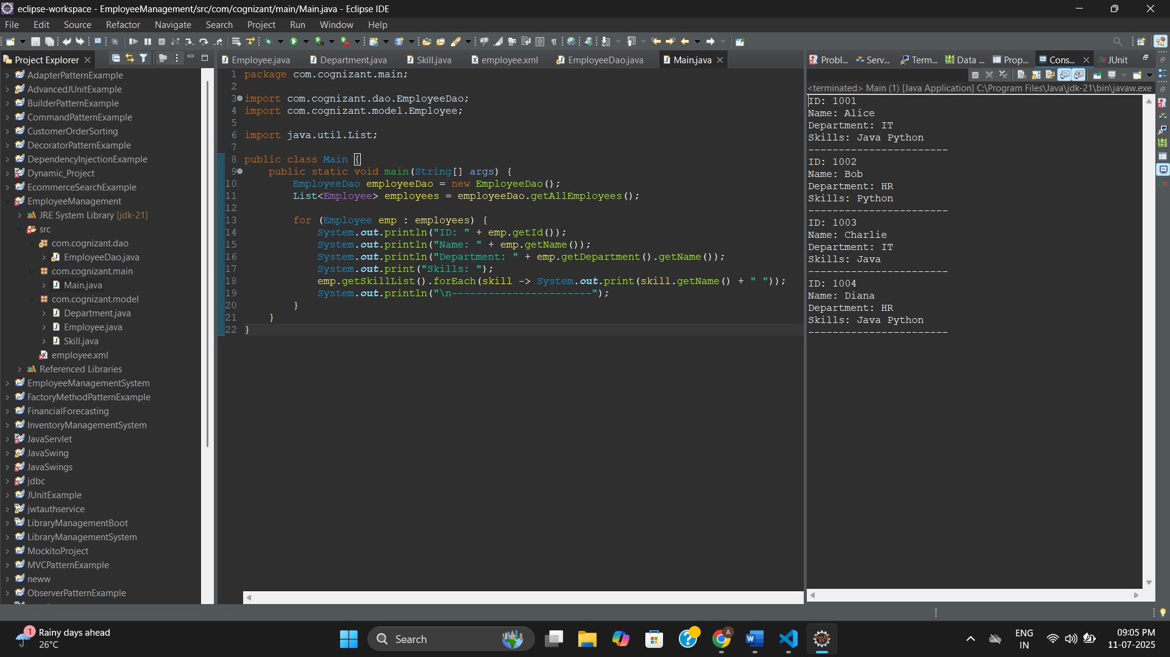

**Create REST service to gets all employees**

**Employee.java**

package com.cognizant.EmployeeManagementSystems.model;

import java.util.List;

public class Employee {

private int id;

private String name;

private double salary;

private Department department;

private List<Skill> skillList;

// Getters and setters

public int getId() { return id; }

public void setId(int id) { this.id = id; }

public String getName() { return name; }

public void setName(String name) { this.name = name; }

public double getSalary() { return salary; }

public void setSalary(double salary) { this.salary = salary; }

public Department getDepartment() { return department; }

public void setDepartment(Department department) { this.department = department; }

public List<Skill> getSkillList() { return skillList; }

public void setSkillList(List<Skill> skillList) { this.skillList = skillList; }

}

**Department.java**

package com.cognizant.EmployeeManagementSystems.model;

public class Department {

private int id;

private String name;

// Getters and setters

public int getId() { return id; }

public void setId(int id) { this.id = id; }

public String getName() { return name; }

public void setName(String name) { this.name = name; }

}

**Skill.java**

package com.cognizant.EmployeeManagementSystems.model;

public class Skill {

private int id;

private String name;

// Getters and setters

public int getId() { return id; }

public void setId(int id) { this.id = id; }

public String getName() { return name; }

public void setName(String name) { this.name = name; }

}

**EmployeeService.java**

package com.cognizant.EmployeeManagementSystems.service;

import java.util.List;

import org.springframework.stereotype.Service;

import jakarta.transaction.Transactional;

import com.cognizant.EmployeeManagementSystems.dao.EmployeeDao;

import com.cognizant.EmployeeManagementSystems.model.Employee;

*@Service*

public class EmployeeService {

private EmployeeDao employeeDao = new EmployeeDao();

*@Transactional*

public List<Employee> getAllEmployees() {

return employeeDao.getAllEmployees();

}

}

**EmployeeController.java**

package com.cognizant.EmployeeManagementSystems.controller;

import java.util.List;

import org.springframework.beans.factory.annotation.Autowired;

import org.springframework.web.bind.annotation.*;

import com.cognizant.EmployeeManagementSystems.model.Employee;

import com.cognizant.EmployeeManagementSystems.service.EmployeeService;

*@RestController*

public class EmployeeController {

*@Autowired*

private EmployeeService employeeService;

*@GetMapping*("/employees")

public List<Employee> getAllEmployees() {

return employeeService.getAllEmployees();

}

}

**EmployeeDao.java**

package com.cognizant.EmployeeManagementSystems.dao;

import java.util.ArrayList;

import com.cognizant.EmployeeManagementSystems.model.Employee;

import org.springframework.context.ApplicationContext;

import org.springframework.context.support.ClassPathXmlApplicationContext;

public class EmployeeDao {

public static ArrayList<Employee> *EMPLOYEE_LIST*;

public EmployeeDao() {

ApplicationContext context = new ClassPathXmlApplicationContext("employee.xml");

*EMPLOYEE_LIST* = (ArrayList<Employee>) context.getBean("employeeList");

}

public ArrayList<Employee> getAllEmployees() {

return *EMPLOYEE_LIST*;

}

}

**employee.xml**

<?**xml** version=*"1.0"* encoding=*"UTF-8"*?>

<**beans** xmlns=*"http://www.springframework.org/schema/beans"*

xmlns:xsi=*"http://www.w3.org/2001/XMLSchema-instance"*

xsi:schemaLocation=*"*

*http://www.springframework.org/schema/beans*

*http://www.springframework.org/schema/beans/spring-beans.xsd"*>

<!-- Skills -->

<**bean** id=*"skill1"* class=*"com.cognizant.EmployeeManagementSystems.model.Skill"*>

<**property** name=*"id"* value=*"1"* />

<**property** name=*"name"* value=*"HTML"* />

</**bean**>

<**bean** id=*"skill2"* class=*"com.cognizant.EmployeeManagementSystems.model.Skill"*>

<**property** name=*"id"* value=*"2"* />

<**property** name=*"name"* value=*"CSS"* />

</**bean**>

<!-- Department -->

<**bean** id=*"dept1"* class=*"com.cognizant.EmployeeManagementSystems.model.Department"*>

<**property** name=*"id"* value=*"101"* />

<**property** name=*"name"* value=*"IT"* />

</**bean**>

<**bean** id=*"dept2"* class=*"com.cognizant.EmployeeManagementSystems.model.Department"*>

<**property** name=*"id"* value=*"102"* />

<**property** name=*"name"* value=*"HR"* />

</**bean**>

<!-- Employee List -->

<**bean** id=*"employeeList"* class=*"java.util.ArrayList"*>

<**constructor-arg**>

<**list**>

<**bean** class=*"com.cognizant.EmployeeManagementSystems.model.Employee"*>

<**property** name=*"id"* value=*"1"* />

<**property** name=*"name"* value=*"John"* />

<**property** name=*"salary"* value=*"50000"* />

<**property** name=*"department"* ref=*"dept1"* />

<**property** name=*"skillList"*>

<**list**>

<**ref** bean=*"skill1"* />

<**ref** bean=*"skill2"* />

</**list**>

</**property**>

</**bean**>

<**bean** class=*"com.cognizant.EmployeeManagementSystems.model.Employee"*>

<**property** name=*"id"* value=*"2"* />

<**property** name=*"name"* value=*"Emma"* />

<**property** name=*"salary"* value=*"55000"* />

<**property** name=*"department"* ref=*"dept2"* />

<**property** name=*"skillList"*>

<**list**>

<**ref** bean=*"skill1"* />

</**list**>

</**property**>

</**bean**>

</**list**>

</**constructor-arg**>

</**bean**>

</**beans**>

**EmployeeManagementSystemsApplication.java**

package com.cognizant.EmployeeManagementSystems;

import org.springframework.boot.SpringApplication;

import org.springframework.boot.autoconfigure.SpringBootApplication;

*@SpringBootApplication*

public class EmployeeManagementSystemsApplication {

public static void main(String[] args) {

SpringApplication.*run*(EmployeeManagementSystemsApplication.class, args);

}

}

**pom.xml**

<?xml version="1.0" encoding="UTF-8"?>

<project xmlns="http://maven.apache.org/POM/4.0.0"

xmlns:xsi="http://www.w3.org/2001/XMLSchema-instance"

xsi:schemaLocation="http://maven.apache.org/POM/4.0.0

https://maven.apache.org/xsd/maven-4.0.0.xsd">

<modelVersion>4.0.0</modelVersion>

<parent>

<groupId>org.springframework.boot</groupId>

<artifactId>spring-boot-starter-parent</artifactId>

<version>3.1.0</version> <!-- You can use 3.5.3 if you're sure it's stable for you -->

<relativePath/>

</parent>

<groupId>com.cognizant</groupId>

<artifactId>EmployeeManagementSystems</artifactId>

<version>0.0.1-SNAPSHOT</version>

<name>EmployeeManagementSystems</name>

<description>Demo project for Spring Boot</description>

<properties>

<java.version>17</java.version>

</properties>

<dependencies>

<!-- Web Starter -->

<dependency>

<groupId>org.springframework.boot</groupId>

<artifactId>spring-boot-starter-web</artifactId>

</dependency>

<!-- Spring Context (to support XML config loading) -->

<dependency>

<groupId>org.springframework</groupId>

<artifactId>spring-context</artifactId>

</dependency>

<!-- Spring Transactional (@Transactional) -->

<dependency>

<groupId>jakarta.transaction</groupId>

<artifactId>jakarta.transaction-api</artifactId>

<version>2.0.1</version>

</dependency>

<!-- Devtools for hot reload -->

<dependency>

<groupId>org.springframework.boot</groupId>

<artifactId>spring-boot-devtools</artifactId>

<scope>runtime</scope>

<optional>true</optional>

</dependency>

<!-- Test -->

<dependency>

<groupId>org.springframework.boot</groupId>

<artifactId>spring-boot-starter-test</artifactId>

<scope>test</scope>

</dependency>

</dependencies>

<build>

<plugins>

<plugin>

<groupId>org.springframework.boot</groupId>

<artifactId>spring-boot-maven-plugin</artifactId>

</plugin>

</plugins>

</build>

</project>

**Output:**

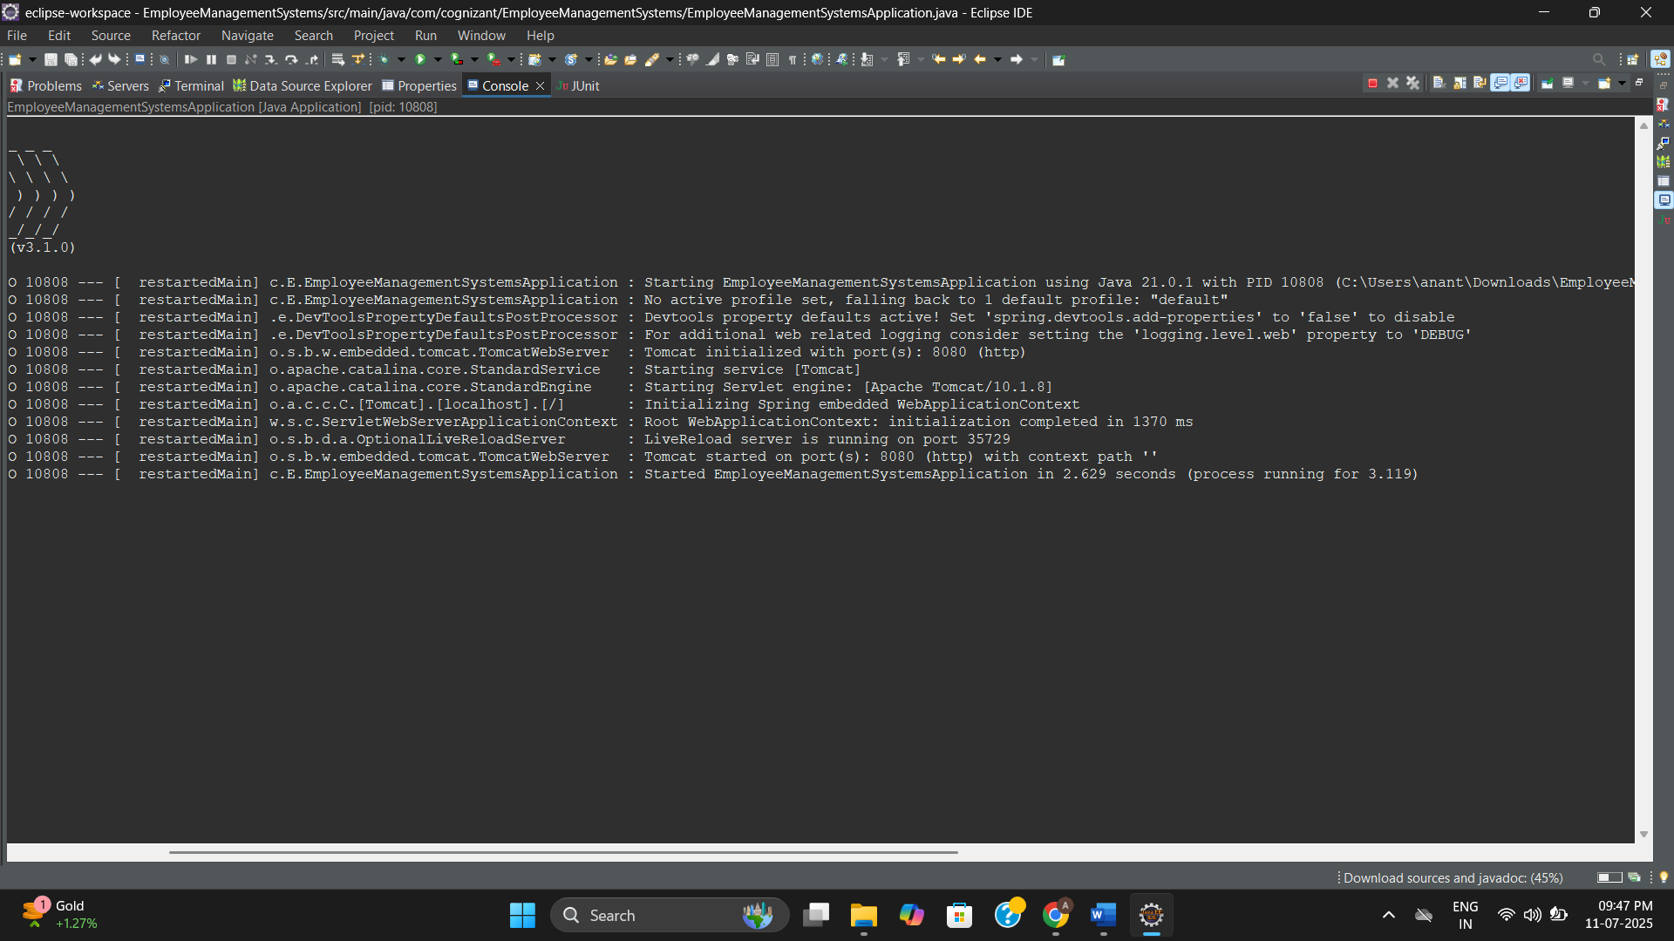

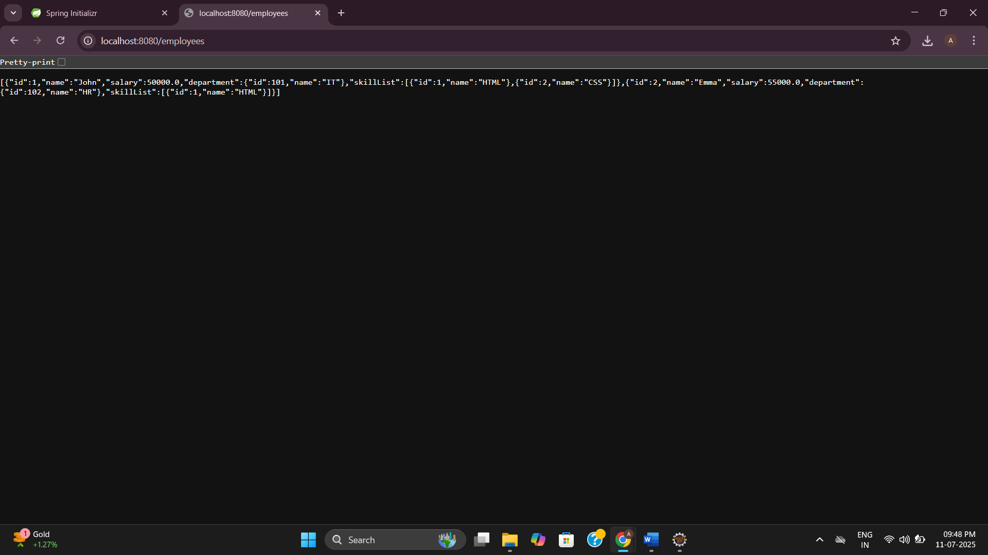

**Create REST service for department**

**Department.java**

package com.cognizant.DepartmentManagement.model;

public class Department {

private int id;

private String name;

// Getters and Setters

public int getId() {

return id;

}

public void setId(int id) {

this.id = id;

}

public String getName() {

return name;

}

public void setName(String name) {

this.name = name;

}

}

**DepartmentController.java**

package com.cognizant.DepartmentManagement.controller;

import com.cognizant.DepartmentManagement.model.Department;

import com.cognizant.DepartmentManagement.service.DepartmentService;

import org.springframework.beans.factory.annotation.Autowired;

import org.springframework.web.bind.annotation.*;

import java.util.List;

*@RestController*

public class DepartmentController {

*@Autowired*

private DepartmentService departmentService;

*@GetMapping*("/departments")

public List<Department> getAllDepartments() {

return departmentService.getAllDepartments();

}

}

**DepartmentService.java**

package com.cognizant.DepartmentManagement.service;

import com.cognizant.DepartmentManagement.dao.DepartmentDao;

import com.cognizant.DepartmentManagement.model.Department;

import org.springframework.stereotype.Service;

import org.springframework.transaction.annotation.Transactional;

import java.util.List;

*@Service*

public class DepartmentService {

private final DepartmentDao departmentDao;

public DepartmentService(DepartmentDao departmentDao) {

this.departmentDao = departmentDao;

}

*@Transactional*

public List<Department> getAllDepartments() {

return departmentDao.getAllDepartments();

}

}

**DepartmentDao.java**

package com.cognizant.DepartmentManagement.dao;

import com.cognizant.DepartmentManagement.model.Department;

import org.springframework.context.ApplicationContext;

import org.springframework.context.support.ClassPathXmlApplicationContext;

import org.springframework.stereotype.Repository;

import java.util.ArrayList;

*@Repository*

public class DepartmentDao {

public static ArrayList<Department> *DEPARTMENT_LIST*;

public DepartmentDao() {

ApplicationContext context = new ClassPathXmlApplicationContext("department.xml");

*DEPARTMENT_LIST* = (ArrayList<Department>) context.getBean("departmentList");

}

public ArrayList<Department> getAllDepartments() {

return *DEPARTMENT_LIST*;

}

}

**department.xml**

**<?xml version=*"1.0"* encoding=*"UTF-8"*?>**

**<beans xmlns=*"http://www.springframework.org/schema/beans"***

**xmlns:xsi=*"http://www.w3.org/2001/XMLSchema-instance"***

**xsi:schemaLocation=*"http://www.springframework.org/schema/beans***

***http://www.springframework.org/schema/beans/spring-beans.xsd"*>**

**<bean id=*"departmentList"* class=*"java.util.ArrayList"*>**

**<constructor-arg>**

**<list>**

**<bean class=*"com.cognizant.DepartmentManagement.model.Department"*>**

**<property name=*"id"* value=*"101"* />**

**<property name=*"name"* value=*"IT"* />**

**</bean>**

**<bean class=*"com.cognizant.DepartmentManagement.model.Department"*>**

**<property name=*"id"* value=*"102"* />**

**<property name=*"name"* value=*"HR"* />**

**</bean>**

**</list>**

**</constructor-arg>**

**</bean>**

**</beans>**

**DepartmentManagementApplication.java**

package com.cognizant.DepartmentManagement;

import org.springframework.boot.SpringApplication;

import org.springframework.boot.autoconfigure.SpringBootApplication;

*@SpringBootApplication*

public class DepartmentManagementApplication {

public static void main(String[] args) {

SpringApplication.*run*(DepartmentManagementApplication.class, args);

}

}

**pom.xml**

<?xml version="1.0" encoding="UTF-8"?>

<project xmlns="http://maven.apache.org/POM/4.0.0"

xmlns:xsi="http://www.w3.org/2001/XMLSchema-instance"

xsi:schemaLocation="http://maven.apache.org/POM/4.0.0

https://maven.apache.org/xsd/maven-4.0.0.xsd">

<modelVersion>4.0.0</modelVersion>

<parent>

<groupId>org.springframework.boot</groupId>

<artifactId>spring-boot-starter-parent</artifactId>

<version>3.5.3</version>

<relativePath/> <!-- Lookup parent from repository -->

</parent>

<groupId>com.cognizant</groupId>

<artifactId>DepartmentManagement</artifactId>

<version>0.0.1-SNAPSHOT</version>

<name>DepartmentManagement</name>

<description>Spring Boot Project for Department Management</description>

<properties>

<java.version>17</java.version>

</properties>

<dependencies>

<!-- Spring Boot Web Starter -->

<dependency>

<groupId>org.springframework.boot</groupId>

<artifactId>spring-boot-starter-web</artifactId>

</dependency>

<!-- Spring Context (for ClassPathXmlApplicationContext) -->

<dependency>

<groupId>org.springframework</groupId>

<artifactId>spring-context</artifactId>

</dependency>

<!-- Spring TX (for transaction if needed) -->

<dependency>

<groupId>org.springframework</groupId>

<artifactId>spring-tx</artifactId>

</dependency>

<!-- DevTools for hot reload -->

<dependency>

<groupId>org.springframework.boot</groupId>

<artifactId>spring-boot-devtools</artifactId>

<scope>runtime</scope>

<optional>true</optional>

</dependency>

<!-- Testing dependency -->

<dependency>

<groupId>org.springframework.boot</groupId>

<artifactId>spring-boot-starter-test</artifactId>

<scope>test</scope>

</dependency>

</dependencies>

<build>

<resources>

<resource>

<directory>src/main/resources</directory>

<includes>

<include>**/*.xml</include>

</includes>

</resource>

</resources>

<plugins>

<!-- Spring Boot Maven Plugin -->

<plugin>

<groupId>org.springframework.boot</groupId>

<artifactId>spring-boot-maven-plugin</artifactId>

</plugin>

</plugins>

</build>

</project>

**Output:**

